H.T No
Regulations:
A20

Sreenidhi Institute of Science and Technology
(An Autonomous Institution)
Code No: 8K404 Date: 04-Mar-2023 (FN)

B.Tech II-Year II- Semester External Examination, February/March-2023 (Supplementary)
MECHANICS OF MATERIALS (CIVIL)

Time: 3 Hours Max.Marks:70

Note: a) No additional answer sheets will be provided.
b) All sub-parts of a question must be answered at one place only, otherwise it will not be valued.
c) Missing data can be assumed suitably.
Bloom's Cognitive Levels of Learning (BCLL)

Remember | L1 | Apply | L3 | Evaluate | L5
Understand | L2 | Analyze | L4 | Create | L6

Part - A Max.Marks:20

Answer all QUESTIONS.

 |  | BCLL | CO(s) | Marks
1 | Discuss Elasticity and Plasticity in briefly. | L2 | CO1 | [2M]
2 | What is Saint-Venant’s principle? | L1 | CO2 | [2M]
3 | Draw the Bending Moment Diagram for simply supported beam with UDL along the span. | L3 | CO3 | [2M]
4 | What are Statically Determinate and Indeterminate Structures? | L2 | CO4 | [2M]
5 | State and explain Principle of Superposition in brief. | L2 | CO5 | [2M]
6 | What are the assumptions made in Euler’s theory? | L1 | CO6 | [2M]
7 | Define Hoop and Longitudinal stress. | L2 | CO1 | [2M]
8 | What is Shear Force and Bending Moment? | L3 | CO3 | [2M]
9 | Explain Maxwell Betties Reciprocal theorem. | L2 | CO5 | [2M]
10 | Define terms: Resilience and Strain Energy. | L1 | CO2 | [2M]

Part – B Max.Marks:50
ANSWER ANY FIVE QUESTIONS. EACH QUESTION CARRIES 10 MARKS.

 |  |  | BCLL | CO(s) | Marks
11. |  | A thin cylinder of internal dia 2.0 m contains a fluid at an internal pressure 3 N/mm², determine the maximum thickness of cylinder if  i) the longitudinal stress is not exceeded 30 N/mm²  ii) the circumferential stress is not exceeded the 40 N/mm². | L5 | CO1 | [10M]
12. | a) | Discuss in detail about tensors and order of tensor quantities. | L2 | CO2 | [3M]
 | b) | Calculate the modulus of rigidity and bulk modulus of cylindrical bar of diameter of 25mm and length 1.6m, if the longitudinal strain is 4 times greater than the four times the lateral strain. Find the change in volume, when bar is subjected hydrostatic pressure of 100 N/mm² when E= 2*10^5 N/mm². | L5 | CO2 | [7M]
13. |  | Draw the Variation of shear force and Bending Moment for below given beam.  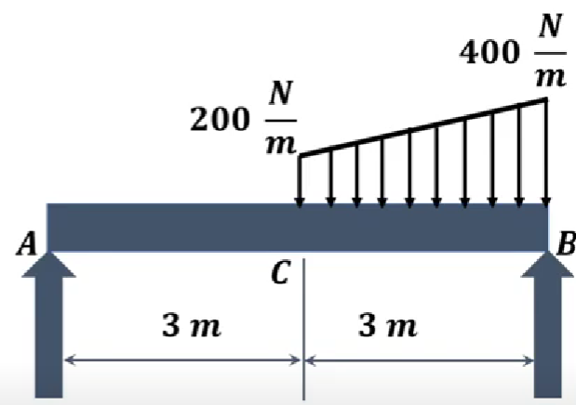 | L5 | CO3 | [10M]
14. |  | Find out Forces of EH, EF, FG and GJ of Given members of truss.  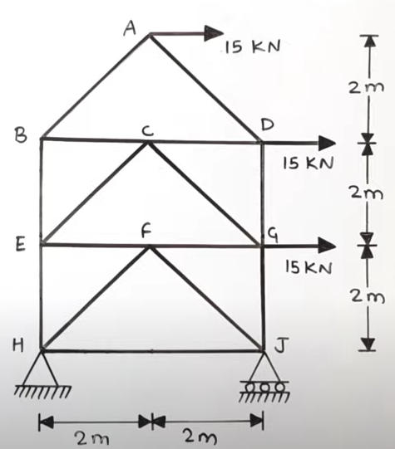 | L5 | CO4 | [10M]
15. | a) | A cantilever beam AB supports a uniform load of intensity q acting over part of the span and a concentrated load P acting at the free end as shown in Fig. Determine the deflection δ_{B} and angle of rotation θ_{B} at end B of the beam. The beam has length L and constant flexural rigidity EI.)  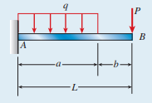 | L5 | CO5 | [7M]
 | b) | Explain Castglianos first theory briefly. | L2 | CO5 | [3M]
16. | a) | Derive the expression for crippling load Eulers Crippling load for columns when column ends are fixed | L3 | CO6 | [5M]
 | b) | A short length of tube 4cm internal dia and 5cm external dia failed in compression at a load 240 kN. When a 2m length of same tube was tested as strut with fixed ends, the load at failure was 158kN. Assuming that Fc in Rankines formula is given by the first test, find the value of constant 'a' in the same formula. What will be crippling load of the tube if it is used as strut 3m long with one end is fixed and other end is hinged. | L5 | CO6 | [5M]
17. | a) | Calculate the circumferential stress for a boiler of 1000mm diameter when it is subjected to an internal pressure of 1MPa. All thickness is such that the safe maximum tensile stress in the boiler material is 35 MPa. Take E=200GPa and μ= 0.25. | L5 | CO1 | [5M]
 | b) | Draw the Variation of shear force and Bending Moment for the below-given beam.  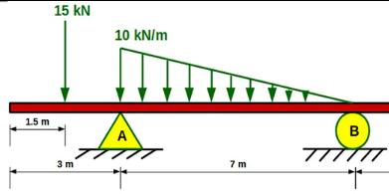 | L3 | CO2 | [5M]
18. | a) | Find out deflection at the center using the Virtual load method.  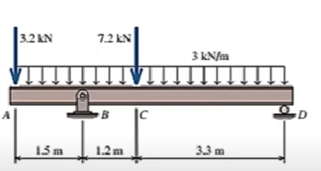 | L5 | CO4 | [5M]
 | b) | What is an equal length of the column? Give the ratios of equal length and actual length of column with various end conditions. | L2 | CO5 | [5M]

-- 00 -- 00 –

